Q1. Explain what Tableau is and why it is preferred over traditional spreadsheet tools for data analysis. Also mention any two industries where Tableau is commonly used and explain one use case.
Ans.
1. What is Tableau?
Tableau is a data visualization and business intelligence tool used to analyze data and create interactive dashboards and reports. It helps users convert raw data into meaningful insights through charts, graphs, and visual storytelling.

2. Why Tableau is Preferred over Traditional Spreadsheet Tools
a) Better Data Visualization
Tableau provides advanced and interactive visualizations, whereas spreadsheet tools (like Excel) mostly rely on basic charts.
b) Handles Large Data Efficiently
Tableau can process and analyze large datasets quickly, while spreadsheets may become slow or crash with heavy data.
c) Interactive Dashboards
Users can apply filters, drill down into data, and explore insights dynamically, which is limited in spreadsheets.
d) Real-Time Data Connectivity
Tableau can connect to multiple data sources (databases, cloud, APIs) and update data in real time.
e) Automation and Refresh
Dashboards can be automatically refreshed, reducing manual effort required in spreadsheets.

3. Industries Where Tableau is Commonly Used
a) Healthcare
b) Retail

4. Use Case Example (Retail Industry)
In the retail industry, Tableau is used to analyze sales performance.
Example:
A retail company uses Tableau to create a dashboard that shows:
- Sales by region
- Product-wise performance
- Monthly revenue trends
This helps managers:
- Identify top-performing products
- Track underperforming regions
- Make data-driven decisions on inventory and marketing

Q2. After connecting to the Sample – Superstore dataset: a) List the main types of fields available (examples: time-based, geographical, numerical). b) Identify any four Dimensions and any four Measures from the dataset.
Ans.
Main Types of Fields in Sample – Superstore Dataset
The dataset contains different types of fields used for analysis:
- Time-Based Fields
  - Used for date-related analysis
  - Examples: Order Date, Ship Date
- Geographical Fields
  - Used to analyze data based on location
  - Examples: Country, State, City, Region
- Categorical Fields (Dimensions)
  - Used to group and segment data
  - Examples: Category, Sub-Category, Segment
- Numerical Fields (Measures)
  - Used for calculations and aggregations
  - Examples: Sales, Profit, Quantity, Discount

b) Examples of Dimensions and Measures
Four Dimensions
- Category
- Sub-Category
- Region
- Customer Name
Four Measures
- Sales
- Profit
- Quantity
- Discount

Q3. Create a Bar Chart showing Total Sales by Category. Explain: Which field goes to Rows Which field goes to Columns Which aggregation is applied to Sales.
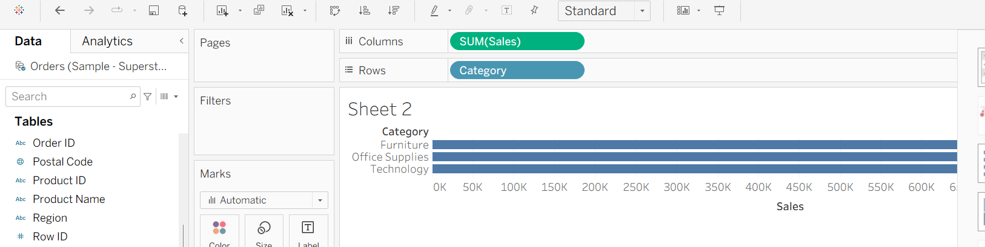

Field Placement
Rows
- Drag Category to the Rows shelf
Columns
- Drag Sales to the Columns shelf

2. Aggregation Applied to Sales
- Tableau automatically applies SUM (Sales)
- This means it calculates total sales for each category

3. Result
- Each bar represents a category (Furniture, Office Supplies, Technology)
- The length of the bar shows the total sales for that category

Q4. What insight can be gained by comparing Sales and Profit together? Then explain how you would create a chart to analyze Profit by Sub-Category. Hint: Use Sub-Category as a Dimension and Profit as a Measure.
Ans.

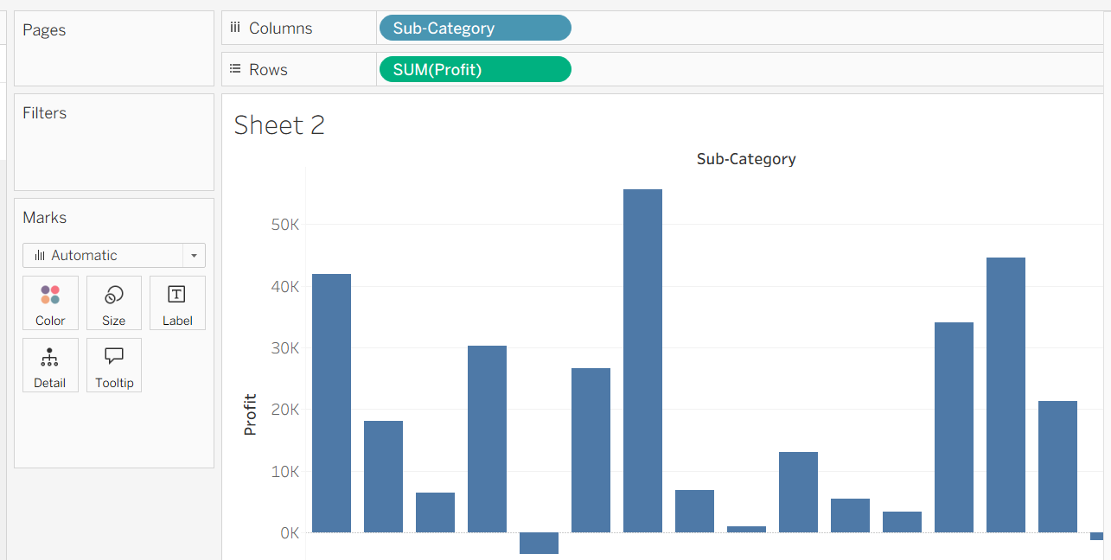

Insight from Comparing Sales and Profit
Comparing Sales and Profit helps identify the true performance of products or categories.
Key insights:
- High Sales but Low/Negative Profit
Indicates that products are selling well but are not profitable (possibly due to high discounts or costs)
- Low Sales but High Profit
Shows niche or premium products that generate good margins despite lower volume
- High Sales and High Profit
Ideal scenario — strong revenue and profitability
- Low Sales and Low Profit
Underperforming areas that may need improvement or discontinuation
Overall, this comparison helps in better decision-making related to pricing, discounts, and product strategy.

2. Creating a Chart to Analyze Profit by Sub-Category
Step 1: Add Dimension
- Drag Sub-Category to the Column shelf
Step 2: Add Measure
- Drag Profit to the Rows shelf
Step 3: Aggregation
- Tableau will automatically apply SUM (Profit)
Step 4: Choose Chart Type
- Use a Bar Chart for clear comparison

3. Result
- Each bar represents a Sub-Category
- The length (or direction if negative) shows total profit
- Negative values help identify loss-making sub-categories

Q5. Create a Line Chart to show Sales Trend over Order Date. Which date level would you choose (Year / Quarter / Month)? Why are line charts suitable for time-based analysis?
Ans.
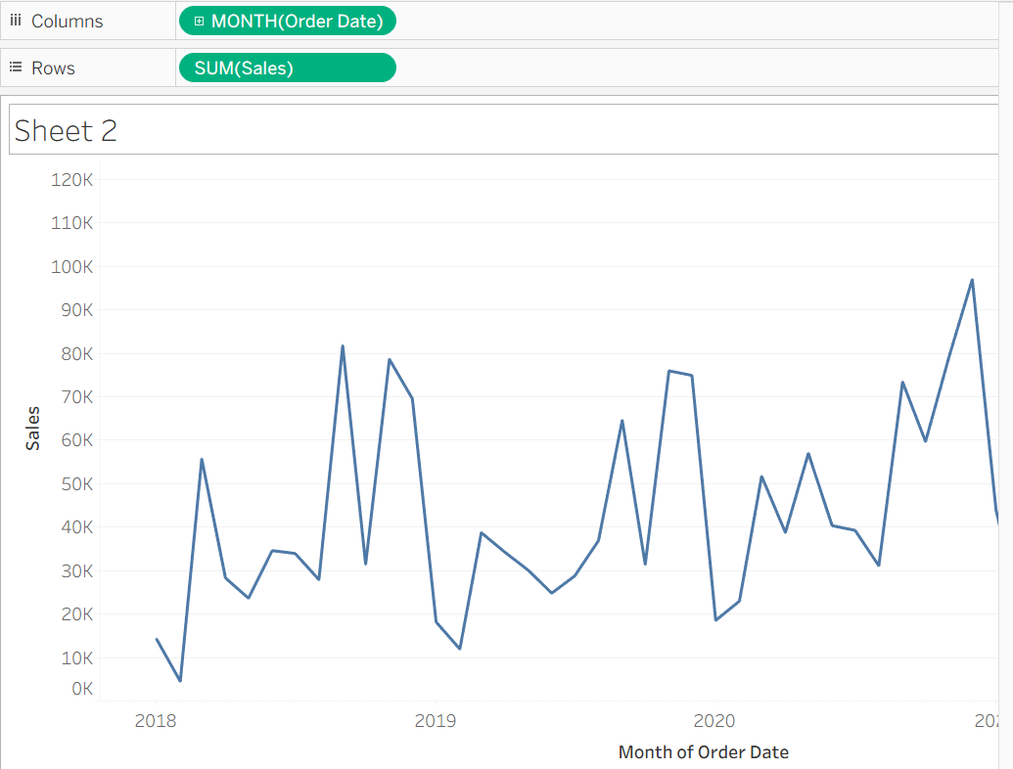

1. Creating a Line Chart for Sales Trend
Step 1: Add Date Field
- Drag Order Date to the Columns shelf
Step 2: Select Date Level
- Choose Month (instead of Year or Quarter)
Step 3: Add Measure
- Drag Sales to the Rows shelf
Step 4: Chart Type
- Tableau will automatically create a Line Chart

2. Which Date Level to Choose and Why
Chosen Level: Month
Reason:
- Provides a good balance between detail and readability
- Shows trends more clearly than Year (too aggregated)
- Less cluttered than Day-level data
- Helps identify seasonality, peaks, and dips in sales

3. Why Line Charts are Suitable for Time-Based Analysis
- Show trends over time clearly
- Display continuous data effectively
- Help identify patterns such as growth, decline, or seasonality
- Make it easy to compare changes between time periods
- Visually intuitive for tracking performance over time

Q6. Apply a Basic Filter to display data only for: Region = “West” Category = “Technology” Explain the steps and mention which shelf is used.
Ans.
1. Steps to Apply Basic Filters
Step 1: Add Region Filter
- Drag Region from the Data pane to the Filters Shelf
- In the filter window, select only “West”
- Click OK

Step 2: Add Category Filter
- Drag Category to the Filters Shelf
- In the filter window, select only “Technology”
- Click OK

2. Shelf Used
- Both filters are applied using the Filters Shelf in Tableau

3. Result
- The view will now display data only for:
  - Region = West
  - Category = Technology
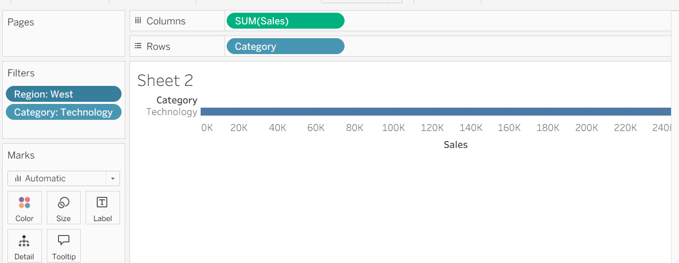

Q7. Explain the business importance of geographical analysis. Then describe how you would create a Map showing Sales by State using Sample – Superstore.

Ans.
1. Business Importance of Geographical Analysis
Geographical analysis helps businesses understand performance across different locations and regions.
Key importance:
- Identifies high-performing and low-performing regions
- Helps in targeted marketing and sales strategies
- Supports better resource allocation (inventory, workforce, budget)
- Enables region-wise comparison for decision-making
- Helps in expansion planning by identifying potential markets
Example: A company can focus more on states with high sales and improve strategies in low-performing areas.

2. Creating a Map Showing Sales by State in Tableau
Step 1: Add Geographical Field
- Drag State to the view (either to the canvas or Marks card)
- Tableau automatically recognizes it as a geographical field and generates a map

Step 2: Add Measure
- Drag Sales to the Color option in the Marks card

Step 3: Adjust Visualization
- Ensure the map type is selected (symbol map or filled map)
- Higher sales will be shown with darker color intensity

Step 4: Optional Enhancements
- Drag Sales to Label to display values
- Add filters (Region, Category) for deeper analysis

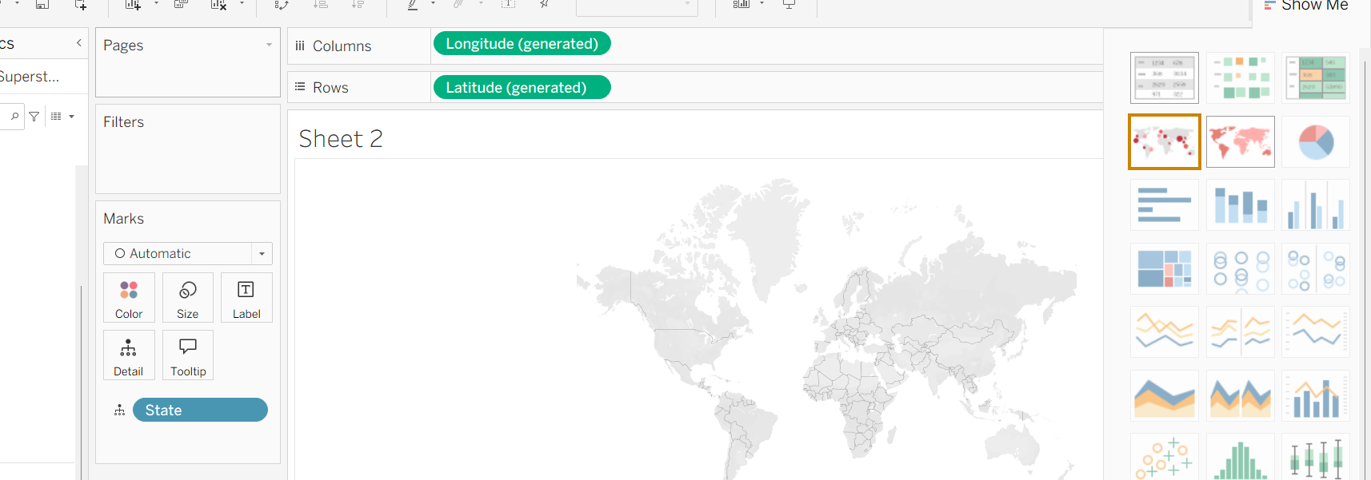

Q8. What is the difference between a Worksheet and a Dashboard in Tableau? Why is a dashboard more useful for decision-makers?
Ans.
1. Difference between Worksheet and Dashboard in Tableau
Worksheet
- A worksheet is a single visualization
- It shows one chart or graph at a time (e.g., bar chart, line chart, map)
- Used for detailed analysis of a specific dataset
- Built using dimensions and measures
Dashboard
- A dashboard is a collection of multiple worksheets combined into one view
- Displays multiple visualizations together (charts, maps, KPIs)
- Can include filters and interactive elements across visuals
- Provides a summarized and comprehensive view of data

2. Why Dashboard is More Useful for Decision-Makers
a) Consolidated View
- Shows multiple insights in one place
- No need to switch between different worksheets
b) Better Decision-Making
- Combines different metrics (sales, profit, trends)
- Helps in understanding the overall business performance
c) Interactivity
- Filters and actions allow users to explore data dynamically
- Clicking one chart can update others
d) Time-Saving
- Quick access to key KPIs and insights
- Reduces time spent analyzing separate reports

Q9. What is Tableau Prep, and why is it important in real-world data projects? Then explain how you would: Remove null values Remove duplicate records Change incorrect data types.
Ans.
1. What is Tableau Prep?
Tableau Prep is a data preparation tool used to clean, transform, and shape raw data before using it in Tableau for analysis and visualization.
It helps in:
- Combining data from multiple sources
- Cleaning messy or inconsistent data
- Structuring data for better analysis

2. Importance in Real-World Data Projects
In real-world scenarios, data is often:
- Incomplete (null values)
- Inconsistent (wrong formats, duplicates)
- Spread across multiple sources
Tableau Prep ensures:
- Clean and reliable data
- Accurate analysis and reporting
- Better performance of dashboards
Without proper data preparation, even the best dashboards can give incorrect insights.

3. How to Perform Common Data Cleaning Tasks
a) Remove Null Values
Steps:
- Open the dataset in Tableau Prep
- Go to the Profile Pane
- Click on the field containing null values
- Select “Null” and choose Exclude
Result:
- All rows with null values in that field are removed

b) Remove Duplicate Records
Steps:
- Add a Clean Step
- Use the Remove Duplicates option
or
- Use Group By on relevant fields to identify duplicates
- Keep only unique records
Result:
- Duplicate rows are removed, ensuring data accuracy

c) Change Incorrect Data Types
Steps:
- In the Profile Pane, locate the field
- Click on the data type icon (e.g., string, number, date)
- Select the correct data type (e.g., change text to date or number)
Result:
- Data becomes usable for correct calculations and analysis

Q10. A retail manager wants answers to the following: Which category generates the highest profit? Which region performs poorly? How does sales change over time? a) Mention which charts you would use b) Identify one key insight that management could derive c) Explain how this helps in business decision-making.

Ans.
Which category generates the highest profit?
Technology generate the highest profit.
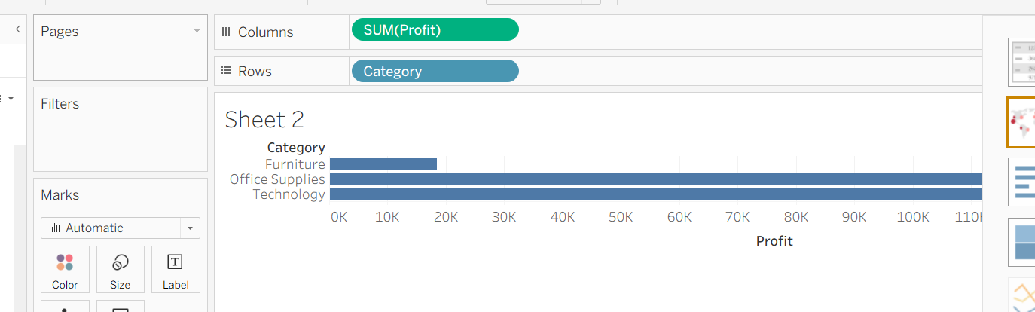

Which region performs poorly?
Central

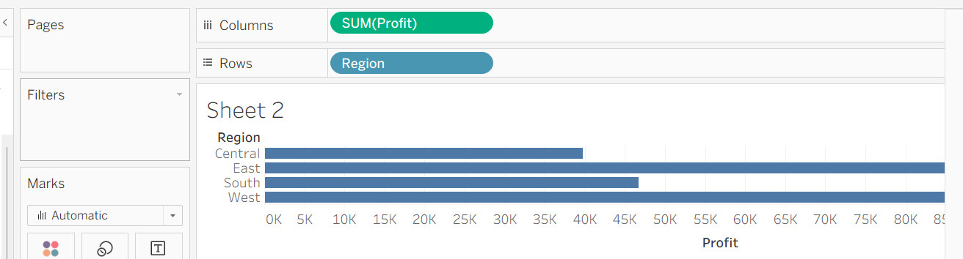

How does sales change over time?

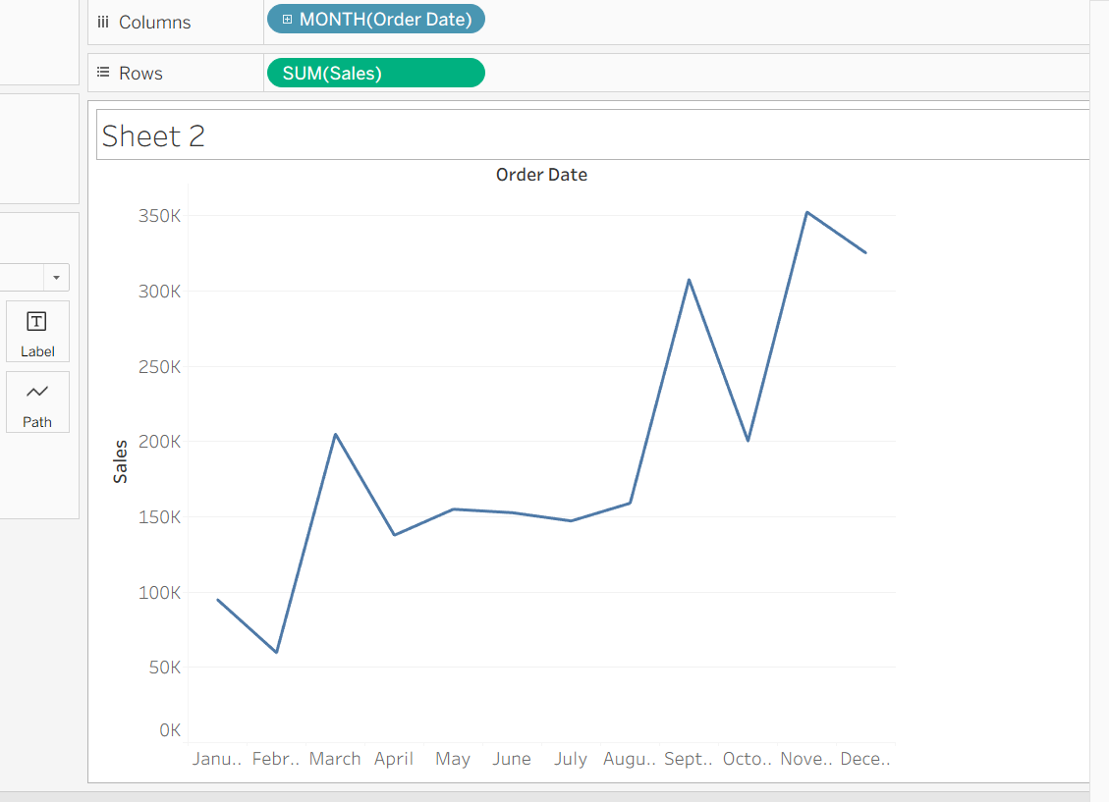

a) Charts to Use
- Which category generates the highest profit
- Use a Bar Chart
- Category on Rows and Profit on Columns
- Which region performs poorly
- Use a Bar Chart or Map
- Region on Rows (or map view) and Profit/Sales as Measure
- How does sales change over time
- Use a Line Chart
- Order Date (Month level) on Columns and Sales on Rows

b) One Key Insight
The analysis may reveal that:
- A specific category (for example, Technology) generates the highest profit
- A particular region (for example, South or Central) is underperforming
- Sales show seasonal trends with peaks during certain months

c) How This Helps in Business Decision-Making
- Profit by Category helps management focus on high-margin products and optimize product strategy
- Region performance helps identify weak areas where corrective actions (marketing, pricing, operations) are needed
- Sales trend over time helps in forecasting demand, planning inventory, and managing workforce

